PDP Routine Quick Audit

Routine audit PDP: 4 July 2024

Github : <https://github.com/selego/doxallia-pdp>

**Api 1**

Summary 1

1. Do we use references or just the id as a string? ( HIGH ) 2

2. We do not use “JOI” for validation, just simple if conditions ( when you migrate to mongoose ) ( HIGH ) 2

Using Joi in the early phases of a project, where frequent changes are common, is not optimal due to the added complexity and increased development time it introduces. The structured nature of Joi's validation hinders rapid iterations based on evolving requirements. 2

3. I do not understand how you are using non-mongoose commands to UserModel which is from “mongoose” ? ( question ) 2

4. Security issue ( HIGH ) 2

**App 3**

5. Use zustand, it is much easier and cleaner than redux ( MEDIUM ) 3

6. We filter all the time in backend ( HIGH ) 3

7. Use early return ( HIGH ) 3

8. Use “ok” of response for early return ( HIGH ) 4

9. Can we keep it simpler with “return”, without using a switch? ( HIGH ) 4

## 

# Api

## Summary

The overall architecture is solid and there are used standard formats for routes and models.

There are just some practices to be changed and “passport” not used in some routes.

## Do we use references or just the id as a string? ( HIGH )

## We do not use “JOI” for validation, just simple if conditions ( when you migrate to mongoose ) ( HIGH )

## Using Joi in the early phases of a project, where frequent changes are common, is not optimal due to the added complexity and increased development time it introduces. The structured nature of Joi's validation hinders rapid iterations based on evolving requirements.

## I do not understand how you are using non-mongoose commands to UserModel which is from “mongoose” ? ( question )

Model imported: <https://github.com/selego/doxallia-pdp/blob/main/api/src/models/user.js>  
Model used: <https://github.com/selego/doxallia-pdp/blob/main/api/src/controllers/user.js>

## Security issue ( HIGH )





# App

## Use zustand, it is much easier and cleaner than redux ( MEDIUM )

## We need to filter all the time in backend ( HIGH )

## Use early return ( HIGH )

This if(!res.ok) return

Instead of:  
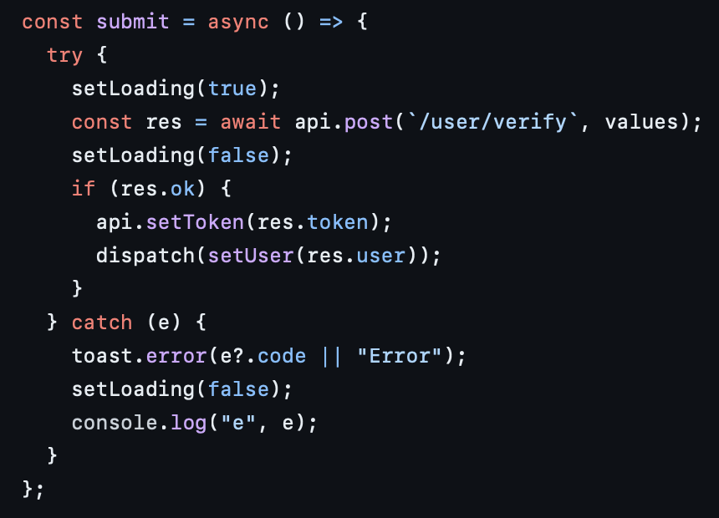

## Use “ok” of response for early return ( HIGH )

## Can we keep it simpler with “return”, without using a switch? ( HIGH )

{view ===”model” && <Model }

